

**DAY 4 - BUILDING DYNAMIC FRONTEND COMPONENTS**

**E-Commerce Website**

**Product: Pudding & Jelly Powders**

**Name: Umehani**

**Roll No: 00364678**

**Day/Time: Friday – 09:00 – 12:00**

**Teacher: Sir Hamzah Syed**

**Day 4 - Building Dynamic Frontend Components for Your Marketplace**

**Key Components to Build:**

1. Product Listing Component:

* Product Name ✔
* Price ✔
* Image ✔
* Example layout: cards displaying product details.

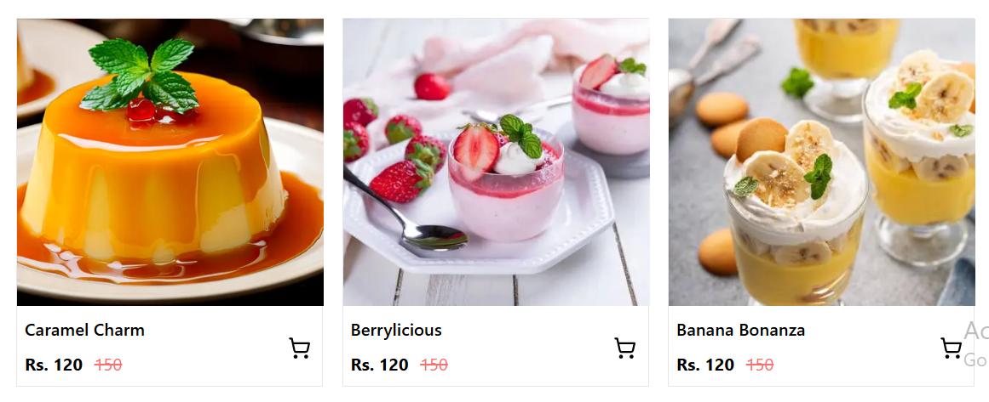

2. Product Detail Component:

* Product Description ✔
* Price ✔
* Delivery Time✔

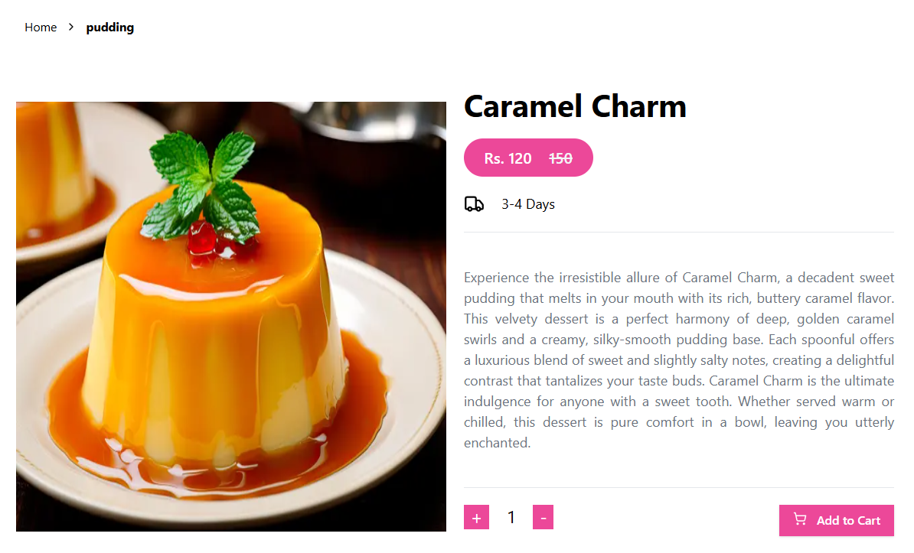

3. Category Component: ✔

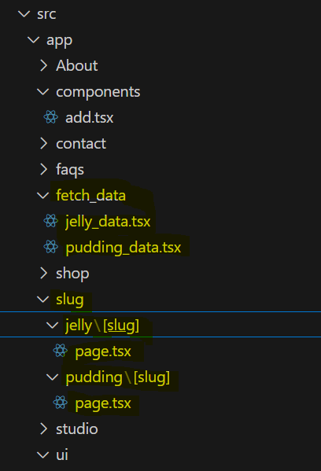

Categories of Products

Pudding & Jelly

4. Search Bar:

* Search functionality to filter products by name or tags. ✔

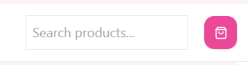

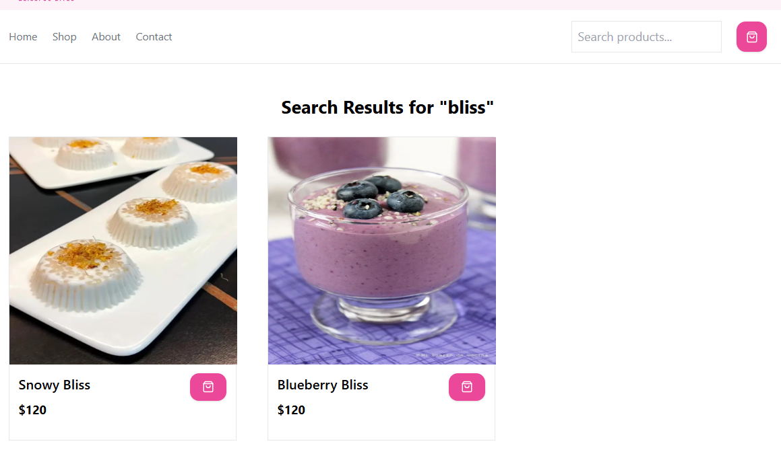

5. Cart Component:

* Display added items, quantity, and total price. ✔
* Use state management for tracking cart items. ✔

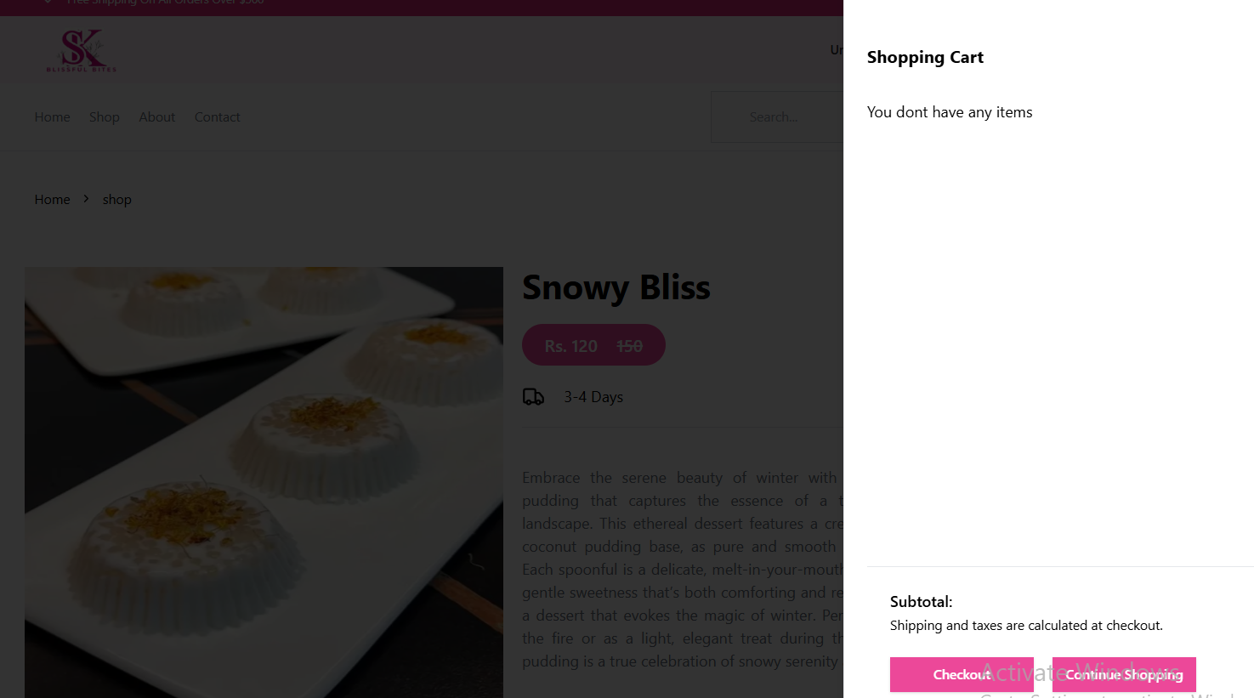 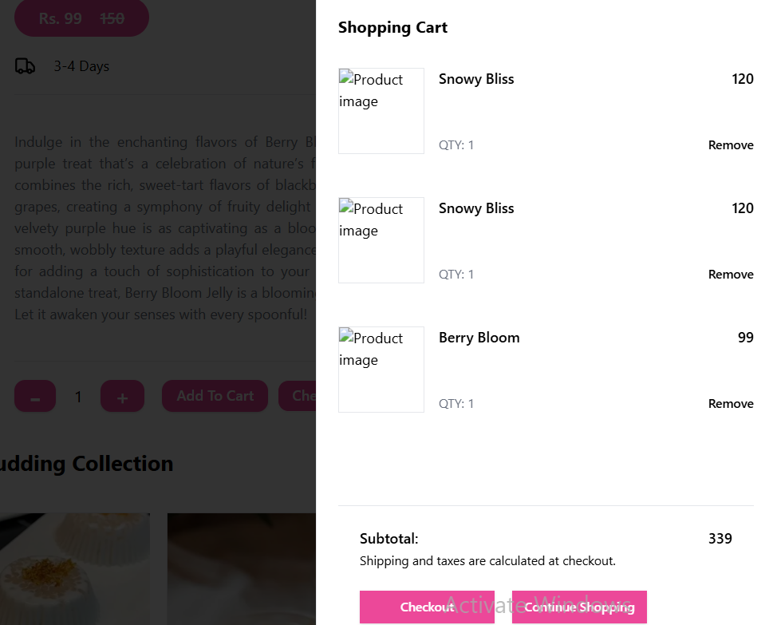

6. Wish list Component:

* Allow users to save products for future reference. ✘
* Use local storage or a global state management tool to persist data. ✘

(Will implement wish list functionality soon.)

7. Checkout Flow Component:

* Billing and shipping address ✔
* Payment details ✔

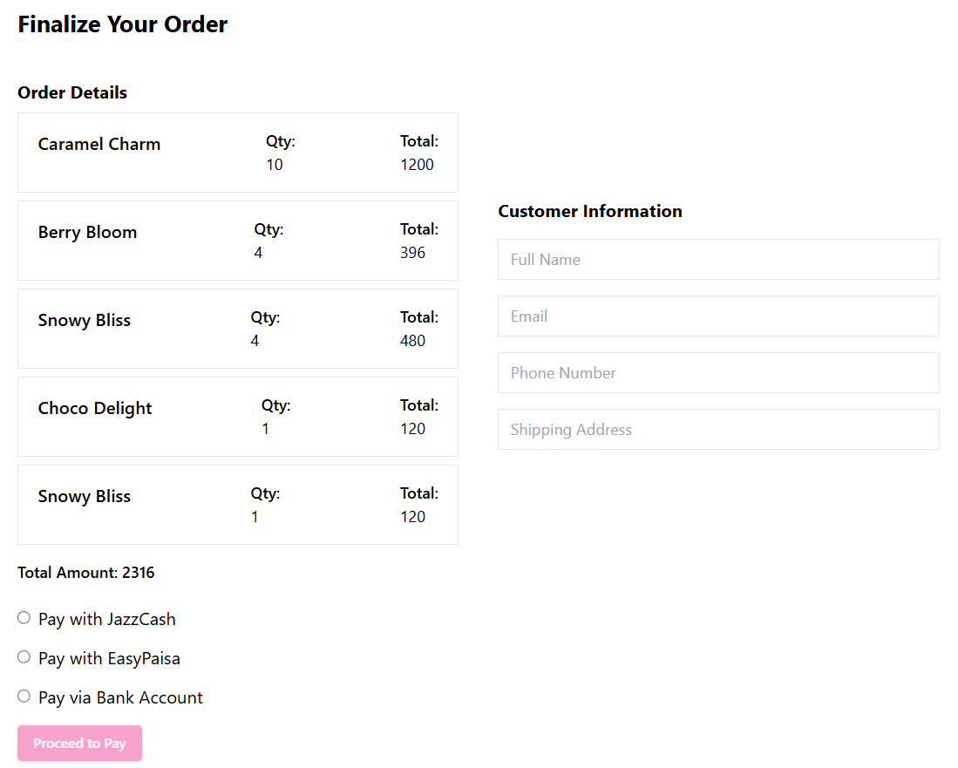

8. User Profile Component:

* Name, email, and saved addresses. ✔
* Order history with links to individual orders.



9. Reviews and Ratings Component:

* Allow users to view and submit reviews for products.
* Display average ratings and individual reviews dynamically.

10. Pagination Component:

* Break down large product lists into manageable pages.
* Implement previous and next buttons or numbered pagination.

11. Footer and Header Components:

* Build consistent navigation and branding elements. ✔
* Include links to key pages (e.g., Home, About, Contact). ✔
* Ensure responsiveness and accessibility. ✔

12. Notifications Component:

* Show real-time alerts for actions like adding to cart, errors, or successful purchases. ✔
* Use toast notifications or modal windows. ✔

13. Analytics Dashboard Component:

* Display key performance indicators (KPIs) like sales, user traƯic, and popular products. (If you don't know how to do it, just add the UI; you may make it dynamic later when you find a way.)
* Use charts and graphs for visual representation.

14. Order Tracking Component:

* Provide users with real-time updates on their order status.
* Include details like estimated delivery time and current location.

15. FAQ and Help Center Component:

* Include a searchable FAQ section. ✔
* Add contact forms or chatbot integrations for support. ✘

16. Subscription Management Component:

* Allow users to subscribe to products or services. (If you don't know how to do it, just add the UI; you may make it dynamic later when you find a way.)
* Manage subscription details and renewal dates.

17. Social Media Sharing Component:

* Enable users to share products or promotions directly to social media platforms.
* Integrate APIs for platforms like Facebook, Twitter, and WhatsApp. (If you don't know how to do it, just add the UI; you may make it dynamic later when you find a way.)

26. Gift Card and Voucher Component:

* Allow users to purchase and redeem gift cards or vouchers.
* Track gift card balances and usage.

27. Customer Feedback Component:

* Create a form for users to submit feedback about the marketplace or specific products. ✔
* Display aggregated feedback for admins to review. ✔



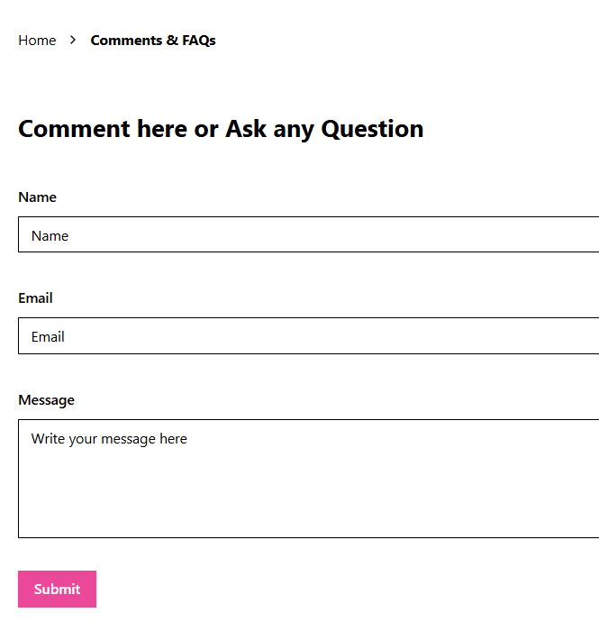 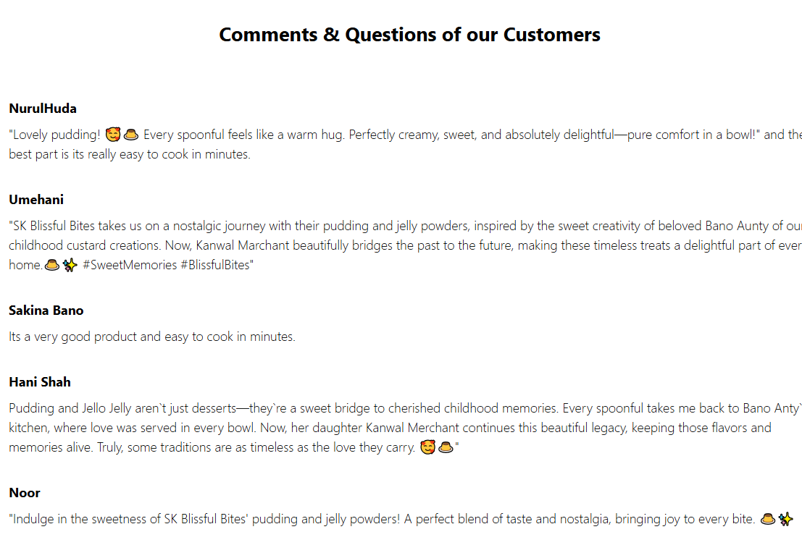

**Overview:**

* There are so many things are remaining to implement and I am working on these functionalities.
* Because of shortage of time and some errors which make me handicap I am submitting my work incomplete.
* This Website is not just for Hackathon I am working on this website to help a lady who make this product at home and now I am trying to help her to enhance her business.